Zavionix RDT sensor and widget Manual
Rev: 01
Date | Writer | Rev | Update
29-9-24 | LZ | 00 | Initial Release
27-3-26 | LZ | 01 | Updated contents

Thank you for using Zavionix RDT sensors and widgets.
The widgets have been designed by a modeler, for modelers and as such, are given to you totally free for personal use.
If you know anybody interested in obtaining the widgets, please refer them to our Github page for their free download:
www.github.com/i3dm/zavionix
If you need an RDT turbine telemetry sensor for your model, please contact: zavionixrc@gmail.com

Sensor Installation
- The RDT sensor has 2 leads, one lead plugs into the GSU (hand data terminal) port on the ECU and the other (Black+Red, Black is Ground and Red is Signal) plugs into the receiver S.port / Smart Port.
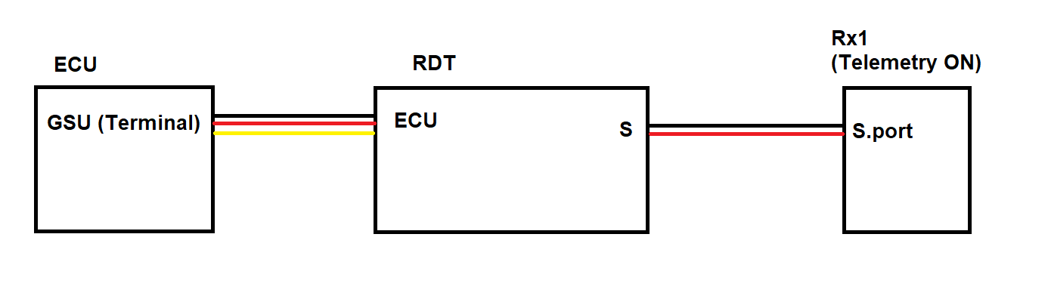
- Note: On some Frsky Recievers you need to assign a channel port as S.port – this is done under RF System Menu, push “Set” next to the receiver, Options and then assign any pin as Smart Port.
- It is recommended to swith OFF telemetry in any other receivers – so to make sure only Rx1 has telemetry and RDT data is always coming through – this is done under RF System Menu, push “Set” next to the receiver, Options and then set telemetry to OFF.
- Note for Projet ECU only: In order to run the telemetry, you must enable the telemetry feature in the ECU, to do so use the GSU (hand data terminal) and find the telemetry menu, and enable it. After that connect RDT and reboot the power.
- Once RDT is properly connected and power is applied to both the ECU and Rx, the RDT should have 2 lights – one solid ON and one blinking. A slow blink (1hz) indicates no ECU data is coming while a fast blink (2hz) indicating live ECU data is coming to the RDT, ensuring a proper ECU connection.
- To discover the RDT sensors in your radio - Go to the "Telemetry" menu and click "discover new sensors". The following sensors should come up: RPM, Temp1, Temp2, ADC3, ADC4.
- RDT also uses some DIY sensors called 0A10, 0A20 and 0A30, depending on ECU type. To discover these go to Telemetry -> DIY Sensor -> Auto Detect. If you have more than one sensor (i.e 0A10, 0A20) then you have to discover one by one, go back to telemetry menu, then repeat the process for the other.
- Only For ECU types Jetcentral, Jetcat and Projet - please edit the settings under DIY 0A10 sensor and choose the following:
Range – change top value from 10000 to Max Value (1000000000)
Protocol Precision/Unit – change from 0 to 0.00

Widget Download to your radio
- Download the latest widgets from: www.github.com/i3dm/zavionix by clicking Code -> Download Zip.
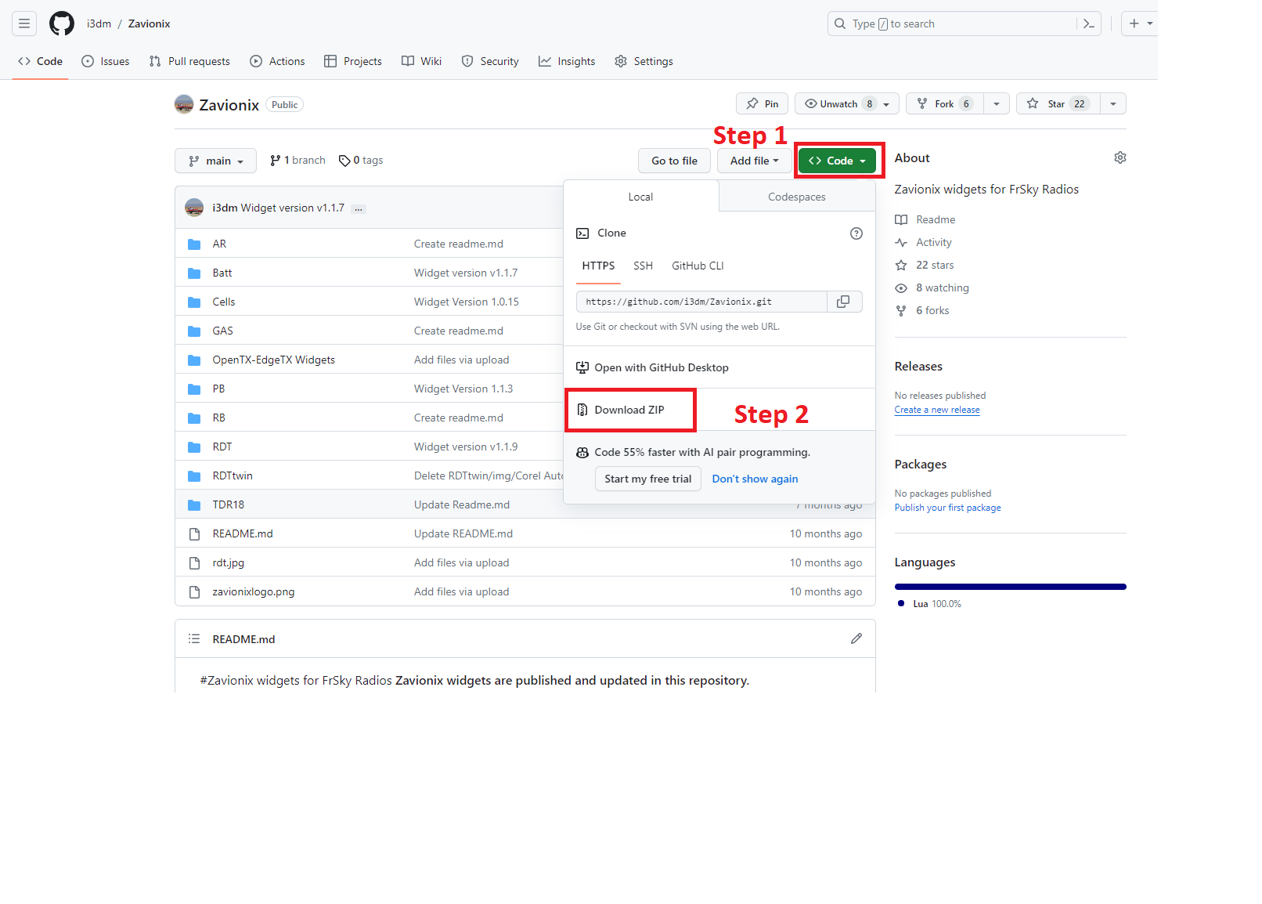
- Downloaded Widget files are usually compressed in ZIP format. If you do not have a tool to extract the ZIP file please download Winrar for free from: www.winrar.com
- Extract the ZIP files, inside it you will find a folder with the widget name (for example: RDT).
- Copy the RDT widget folder to the SD card “scripts” folder. If this folder does not exist on your SD card, please create a folder called scripts on the root of the SD.
- For example, for RDT widget, the SD should have a folder called scripts, inside it a folder called RDT and inside it the main.lua and all other files.
- If you accidentally created any sub folders in the process, the widget will not work. So please make sure #5 and #6 are done correctly.

Widget Installation
- Once all files have been copied, start your Ethos radio.
- Go to screens menu (DISP button on left dial from main screen).
- Add a new screen (screen 2 for example).
- Choose screen layout. RDT needs FULL SCREEN (bottom left option in the photo):
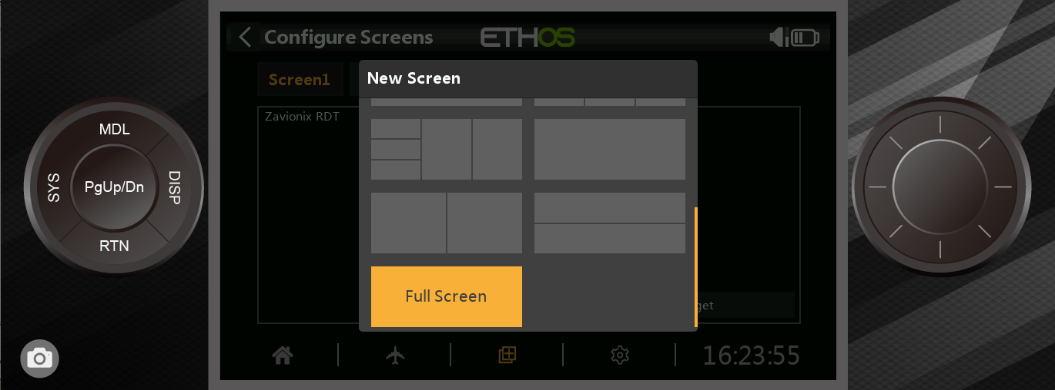
- Select “Configure Widget” and choose the appropriate widget from the list – Zavionix RDT.
- Exit back to main screen.
- Scroll to widget page using the Page button.
- Once you are on the widget screen, click Enter (center of right rotary knob) and Configure Widget.
- In the widget setting go through every line and choose the appropriate option (sensor sources, alert parameters etc).
the sensor allocation list per ECU type can be found in the attached Excel sheet:
RDT sensor configuration for Ethos.xls
- Click RTN a few times to Exit back to main page.
Setting up the fuel quantity report in the RDT widget
- The following ECUs report their own fuel amount without requiring any calibration:
  - Projet / Hornet
  - Jetcat (all versions)
  - Jetcentral SE
Note: For all of the above ECUs:
1. fuel tank size is set in the ECU (using the GSU / hand data terminal)
2. Fuel tank size in widget settings should be set to match. For example if your ECU is set to 1234ml then widget settings should be set to 1234ml as well.
3. Therefore, the fuel calibration is not relevant for the above ECU types.

Calculated Fuel quantity and Fuel Factor Calibration
All other ECUs must go through the following calibration process to get an accurate fuel consumption reading:
- Note your current fuel factor, for this example we will use the default value of 100.
- Define your fuel tank size in the widget, for the example lets assume 3000ml.
- Fly / run the model with a known amount of fuel, for this example lets assume 1000ml was burned during the flight.
- note the remaining fuel amount indicated by the widget, lets assume widget shows 1500ml left.
- New factor calibration is:
$$old factor *\frac{ (Actual Burned fuel amount}{tank size – remaining fuel indicated by the widget}$$In our example:
$$Calibrated fuel factor=100*\frac{ 1000}{3000-1500}=66.6$$
- Define the new fuel factor in the widget settings.
- Define a fuel level alert of your liking and enjoy this amazing feature

Setting up the Engine Cut alert
- In the widget settings, set "Engine Cut Alert" to ON
- Set engine cut alert rate to your liking (default is every 5 seconds)
- Set the RPM from which you want the engine cut alert to sound in multiplies of 100, for example if you wish for the engine cut alert to sound under 30,000 RPM, set this value to 300.
- Note: ewe recommend to set the engine cut RPM to 5000 RPM under idle, for example if your turbine idles at 30,000 rpm, set to 250 (e.g 25,000 rpm)

Thank you for using Zavionix and if you have any questions please contact us via email: zavionixrc@gmail.com
If you like our work and would like to show your appreciation, a donation goes a long way to keep the free work going, and you may do so by using paypal: zavionixrc@gmail.com
Thank you.

